Bushra Akter

Class Number : 09

Date : 05 Oct 2024

**Lab part (Assignment) –** Latest Microsoft Vulnerability Details

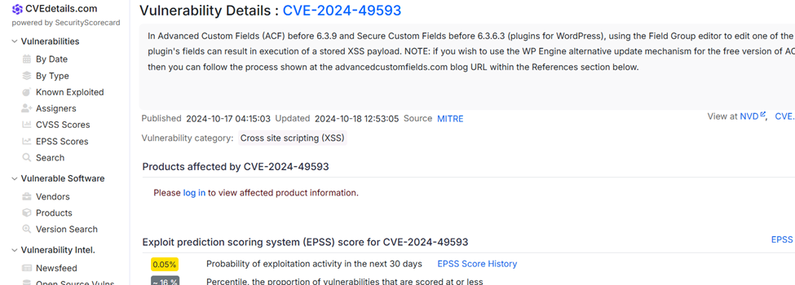

leakix.net/ à

<https://threatmap.checkpoint.com/> à live attack protocal

[LeakIX - Graph](https://leakix.net/graph?) a check live vulnerability

72.249.68.156à juniv.edu

<https://www.whois.com/> a domain name,identity,ip

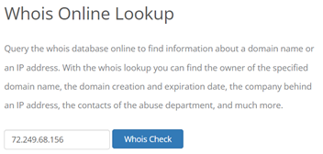

<https://who.is/> à inp

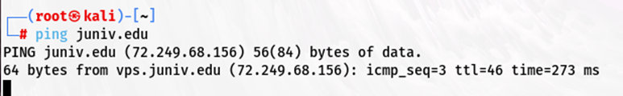

Information gathering:

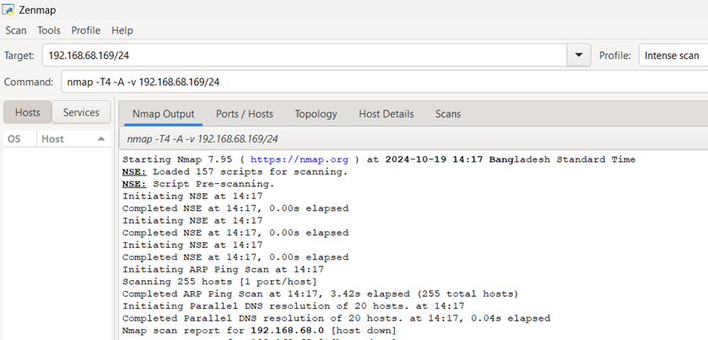

<https://www.ipvoid.com/> target ip details

A mean ip address it’s call A record

Nessus/tenable security centerà vulnerability scaner

Nessus installationàH.W à scan hoy policyr against e PN7W-Z9BP-KNM7-ZF5A-5NXP

SLA à service level argument

[Download Burp Suite Community Edition - PortSwigger](https://portswigger.net/burp/communitydownload)

<https://www.abuseipdb.com/> à to send a ip in black list

<https://any.run/>

<https://any.run/malware-reports/>

<https://app.any.run/submissions/>

<https://app.any.run/tasks/eaedffff-3e09-4c96-8bce-8f94950eaf7b>